SET 17: EMPLOYEE PERFORMANCE ANALYSIS

Dataset | Employee Performance
Department | AIDS
Course Code / Course Name | DSA0602 / Data Handling and Visualization
Experiment | Data Visualization using R
Name | GOPIKHA S
Register Number | 1924260143
Date | 10 October 2026
Day | Saturday

Dataset: Employee Performance

Employee ID | Department | Years of Service | Performance Score
1 | Sales | 5 | 85
2 | HR | 3 | 92
3 | Marketing | 7 | 78

PROGRAM 1: Line Chart of Performance Trend
Question: Create a line chart to visualize the performance trend of employees over time. Label the axes and title the chart.
# Dataset
years_of_service <- c(5, 3, 7)
performance_score <- c(85, 92, 78)

# Arrange the data in order of years of service ord <- order(years_of_service)

# Line Chart
plot(years_of_service[ord], performance_score[ord], type = "o",
main = "Employee Performance Trend by Years of Service", xlab = "Years of Service",
ylab = "Performance Score", col = "blue",
pch = 16,
ylim = c(70, 100), xaxt = "n")
axis(1, at = years_of_service[ord])

# Label each point
text(years_of_service[ord], performance_score[ord], labels = performance_score[ord], pos = 3)

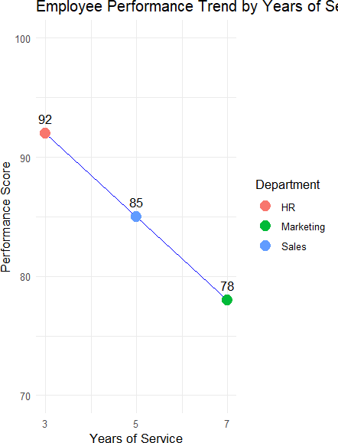

Output 1: Employee Performance Line Chart
Observation: The line chart shows the performance score falling as years of service increase: 92 at 3 years (HR), 85 at 5 years (Sales) and 78 at 7 years (Marketing).

PROGRAM 2: Bar Chart of Employees by Department
Question: Generate a bar chart showing the distribution of employees across different departments. Label the chart elements.
# Department data
department <- c("Sales", "HR", "Marketing")

# Calculate frequency dept_count <- table(department)

# Bar Chart
bp <- barplot(dept_count,
main = "Number of Employees by Department", xlab = "Department",
ylab = "Number of Employees",
col = c("lightgreen", "orange", "skyblue"), ylim = c(0, 1.3))

# Label each bar
text(bp, dept_count, labels = dept_count, pos = 3)

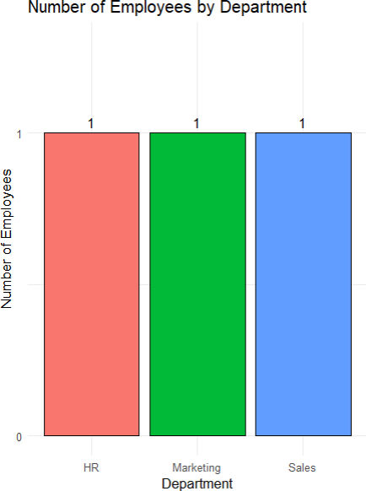

Output 2: Employees by Department Bar Chart
Observation: The bar chart shows that each of the three departments (HR, Marketing and Sales) has exactly one employee in the given dataset.

PROGRAM 3: Employee Performance Data Table
Question: Build a table to display the performance data for each employee. Label the table elements.
# Employee Performance Dataset employee_data <- data.frame(
Employee_ID = c(1, 2, 3),
Department = c("Sales", "HR", "Marketing"), Years_of_Service = c(5, 3, 7),
Performance_Score = c(85, 92, 78)
)

# Display the table print(employee_data)

Employee_ID Department Years_of_Service Performance_Score
1 | 1 | Sales | 5 | 85
2 | 2 | HR | 3 | 92
3 | 3 | Marketing | 7 | 78

Output 3: Employee Performance Data Table
Observation: The table displays the Employee ID, Department, Years of Service and Performance Score for each of the three employees.

PROGRAM 4: Interactive Tableau Dashboard
Question: Develop a Tableau dashboard combining the line chart, bar chart, and the table for interactive exploration of employee performance data.

Tableau Steps
- Open Tableau and connect to the Employee Performance dataset.
- Verify the fields Employee ID, Department, Years of Service and Performance Score.
- Create a worksheet for the line chart: drag Years of Service to Columns and Performance Score to Rows; select Line in the Marks card.
- Add the title “Employee Performance Trend” and label the axes.
- Create a second worksheet: drag Department to Columns and Number of Records (or COUNT(Employee ID)) to Rows; select Bar in the Marks card.
- Add the title “Employees by Department” and label the axes.
- Create a third worksheet and drag Employee ID, Department, Years of Service and Performance Score into the view to form the performance table.
- Create a new Dashboard and add the line chart, bar chart and table.
- Add the title “Employee Performance Dashboard”.
- Use the bar chart (Department) as a filter by clicking “Use as Filter” to make the dashboard interactive.
- Test the dashboard by selecting a department and checking the linked views.
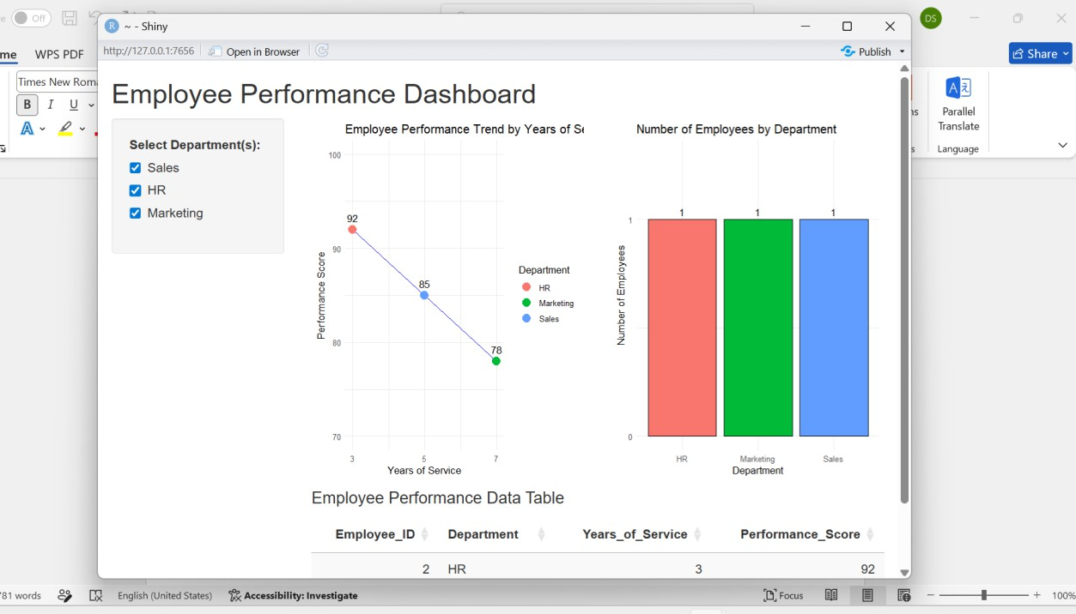

Output 4: Employee Performance Dashboard
Observation: The Tableau dashboard combines the performance line chart, department bar chart and performance table, allowing interactive exploration of employee performance data.

Procedure
- Create the employee performance data in R.
- Arrange the data by years of service and create the line chart using plot() with type = "o".

- Prepare the department data, calculate frequencies using table(), and create the bar chart using barplot().
- Create a data frame containing Employee ID, Department, Years of Service and Performance Score and display it as a table.
- Open Tableau and import the Employee Performance dataset.
- Create the performance line chart and department bar chart in Tableau.
- Create the employee performance table in Tableau.
- Combine the three visualizations into an interactive dashboard and add a suitable title.
- Test the dashboard using the available filter/interactivity.

Result
The Employee Performance data was successfully visualized using a line chart, bar chart, performance data table, and an interactive Tableau dashboard.

